**INDIA AGRICULTURE CROP PRODUCTION**

**1. INTRODUCTION**

**1.1 Overview**

It is an initiative aimed at studying and improving the agricultural sector in India, particularly focusing on crop production. India has a predominantly agrarian economy, and crop production is a vital component of its agricultural sector. This project seeks to address various aspects of crop production in India, including crop yield enhancement, sustainability, and overall agricultural productivity.

**1.2 Purpose**

It has several important objectives and potential outcomes that can be achieved to benefit India's agricultural sector and the country as a whole. Some of the key achievements and benefits that can result from this project include:

* Increased Crop Yields: By implementing modern agricultural practices, improved crop varieties, and sustainable farming methods, the project can significantly increase the yield of major crops. This can lead to higher agricultural productivity, greater food availability, and improved income for farmers.
* Food Security: Higher crop yields can contribute to food security by ensuring an adequate and stable food supply for the growing population of India. This can help in reducing food shortages and price fluctuations.
* Income Generation: Improved crop production can lead to increased income for farmers, thereby reducing rural poverty and improving the livelihoods of those dependent on agriculture.
* Sustainability: The project can promote sustainable farming practices, including responsible water usage, reduced chemical inputs, and environmentally friendly agriculture. This contributes to the long-term sustainability of Indian agriculture and reduces its ecological footprint.
* Technological Advancements: Encouraging the adoption of modern agricultural technologies and digital tools can make farming more efficient, reduce labor intensity, and increase the precision of resource utilization.
* Diversification: Promoting crop diversification can reduce the risks associated with mono-cropping and provide opportunities for farmers to cultivate high-value crops, thus increasing their income potential.
* Improved Infrastructure: Investing in rural infrastructure, such as roads and storage facilities, can enhance market access, reduce post-harvest losses, and facilitate the transportation of agricultural produce to consumers, thereby improving the overall supply chain.
* Education and Training: Providing training and education to farmers can enhance their skills and knowledge, enabling them to make informed decisions about crop management and adopt best practices in agriculture.
* Research and Development: Support for agricultural research can lead to the development of new crop varieties that are better adapted to local conditions, more resistant to pests and diseases, and potentially higher in nutritional value.
* Policy Support: Advocating for and implementing policies that support the agricultural sector can create a favorable environment for farmers and encourage investment in agriculture.
* Rural Development: The project can stimulate rural development by increasing agricultural productivity, income, and employment opportunities in rural areas.
* Economic Growth: A thriving agricultural sector can contribute significantly to the country's economic growth, reduce rural-urban migration, and support overall economic stability.

It aims to enhance food security, increase the income of farmers, promote sustainable agriculture, and drive economic growth. Its successful implementation can lead to a more prosperous and sustainable agricultural sector in India, benefiting both farmers and the nation as a whole.

**2. PROBLEM DEFINITION & DESIGN THINKING**

**2.1 Empathy Map**

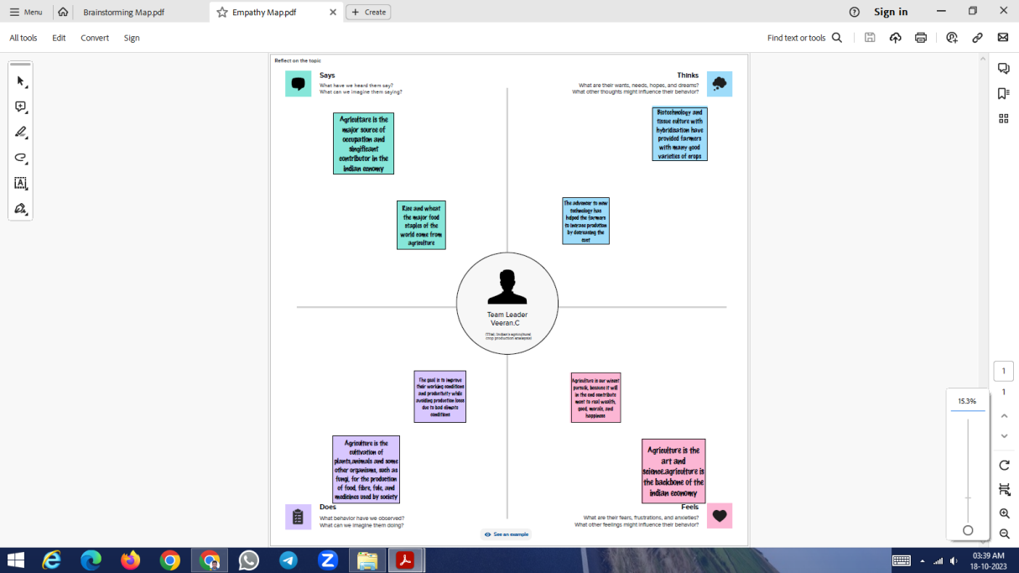

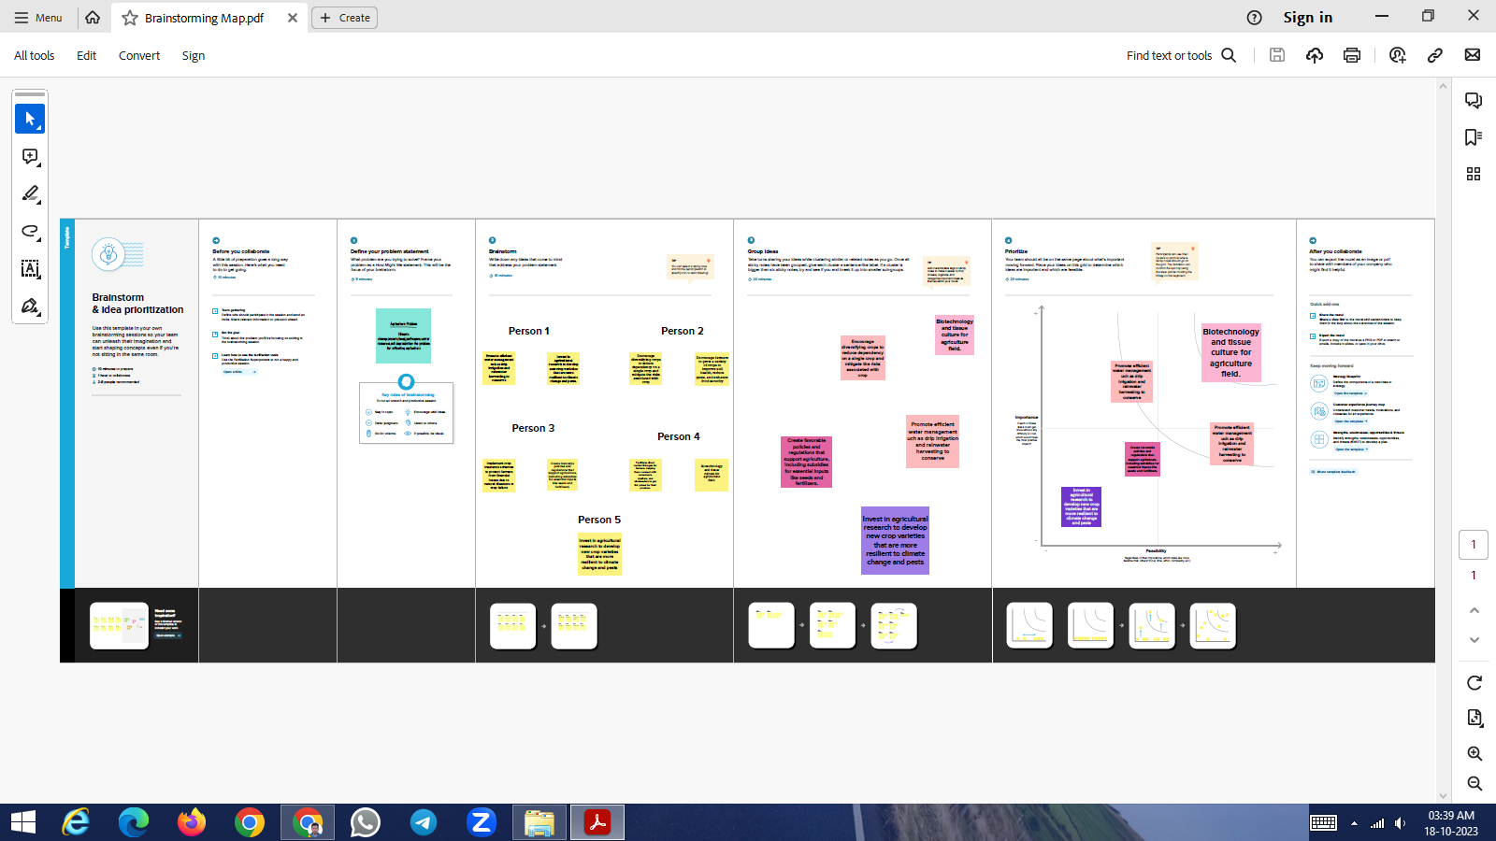**2.2 Ideation & Brainstorming Map**

**3. RESULT**

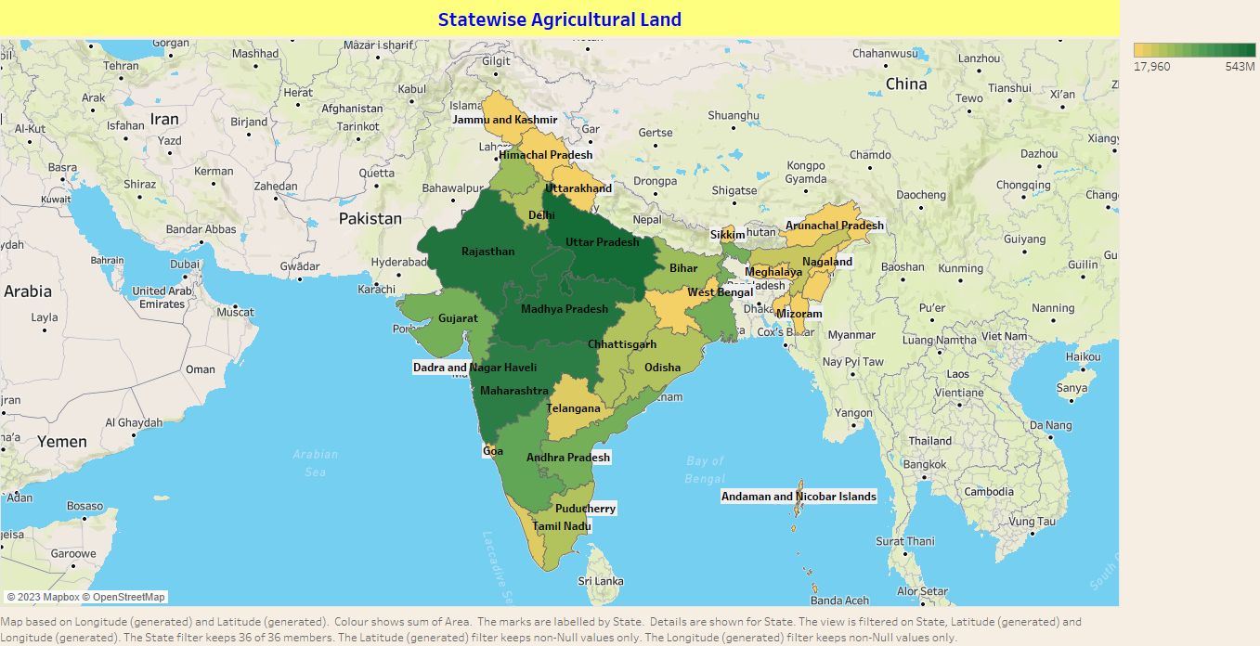

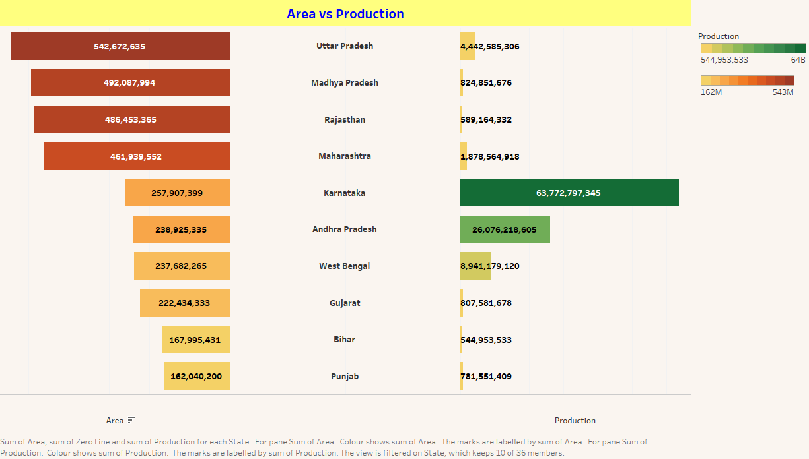

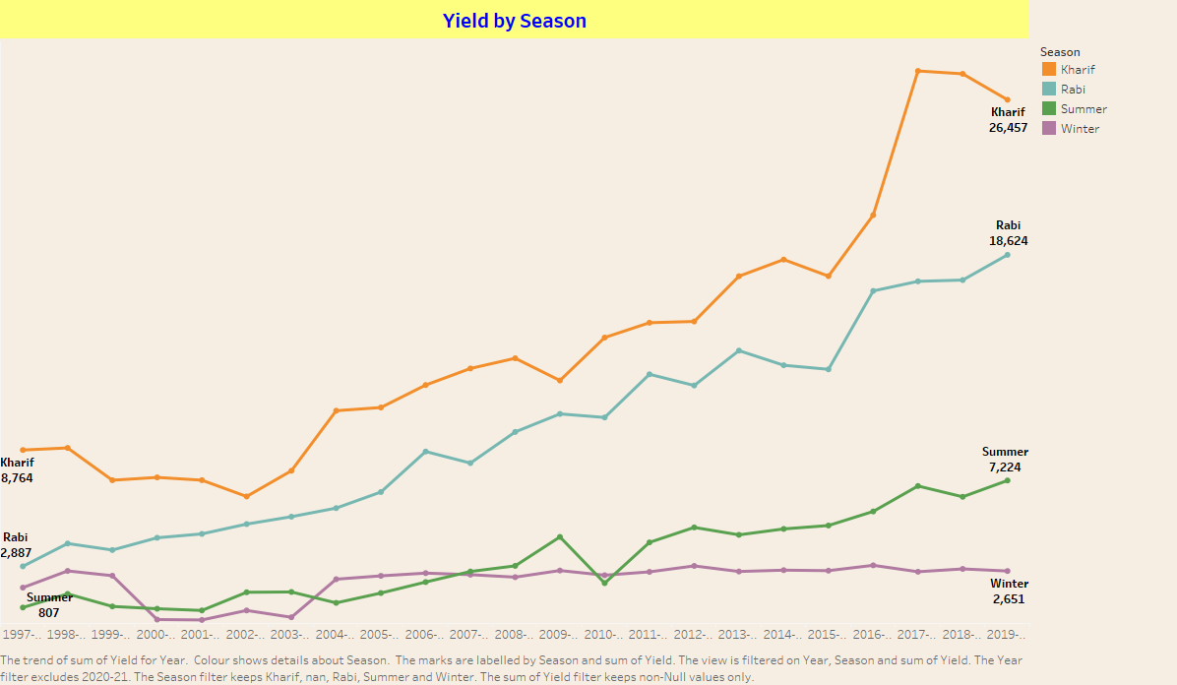

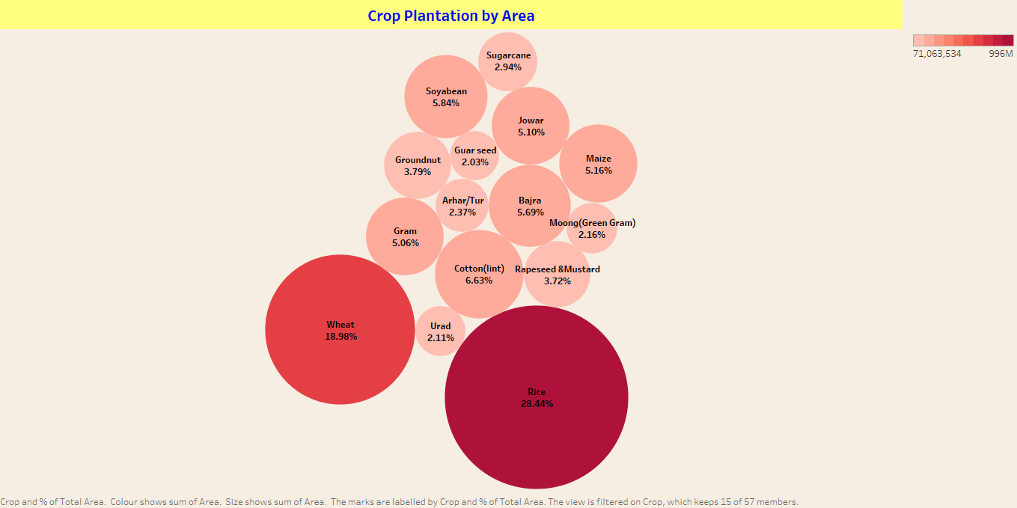

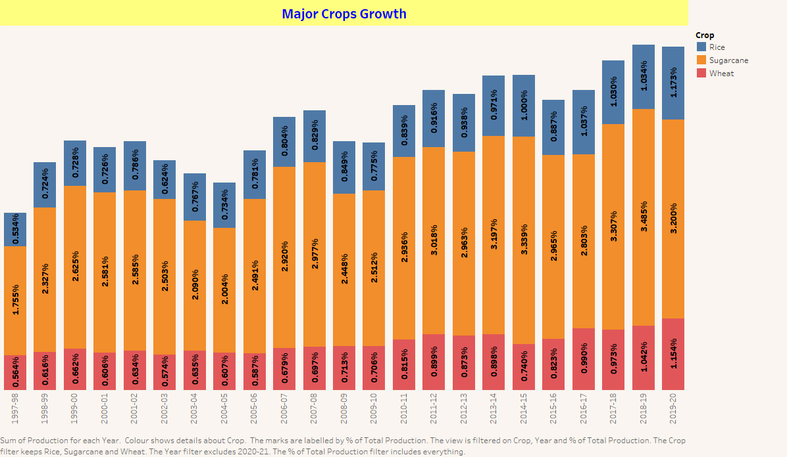

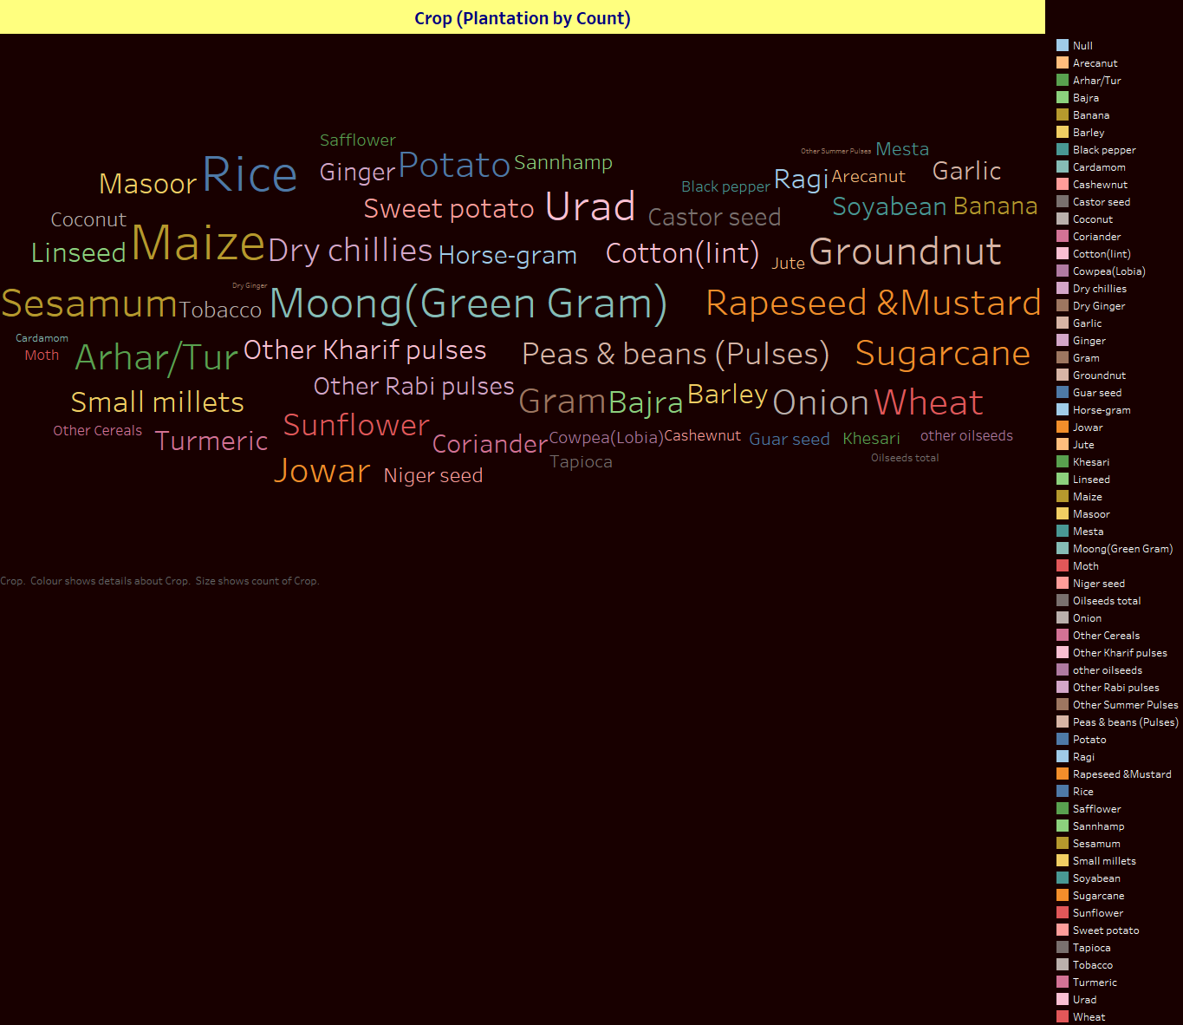

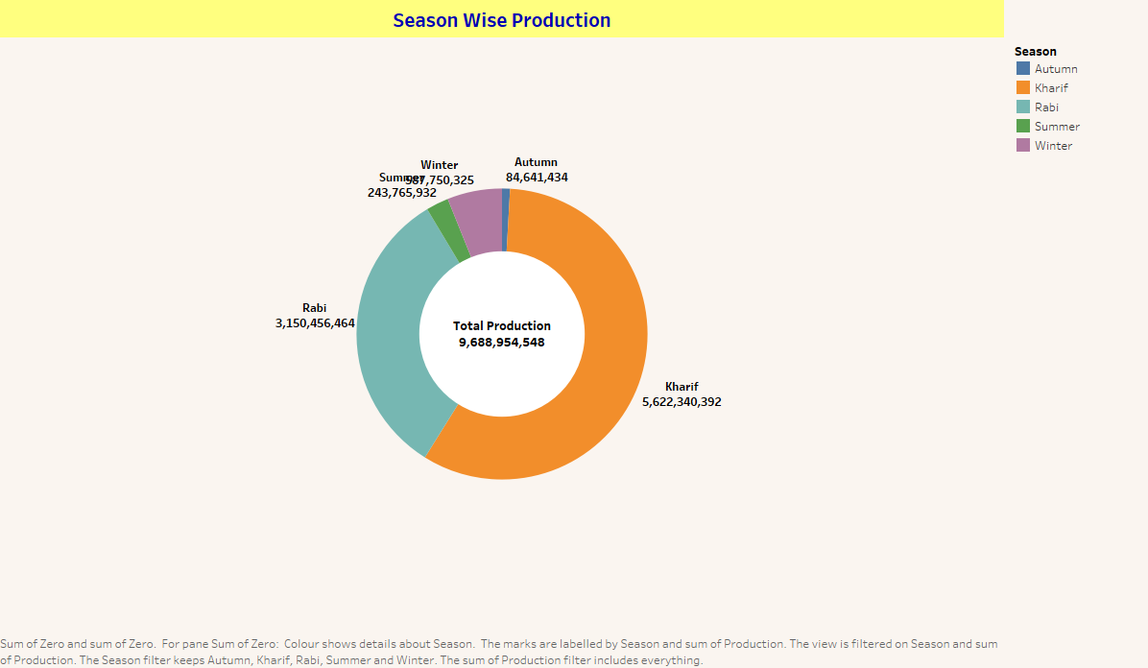

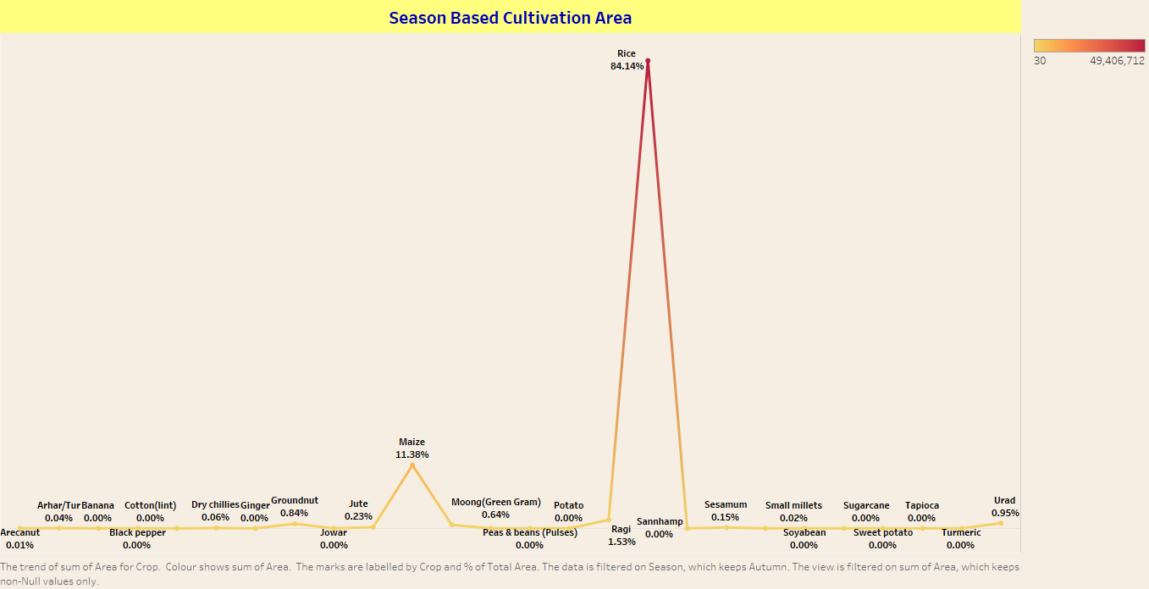

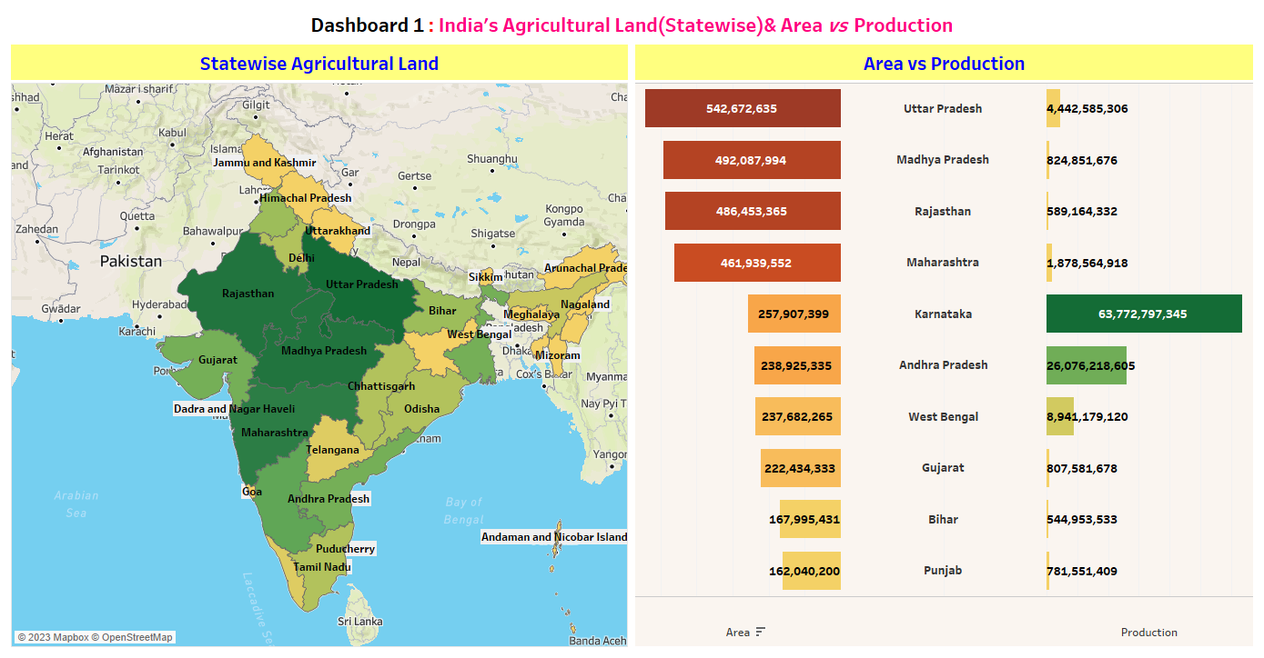

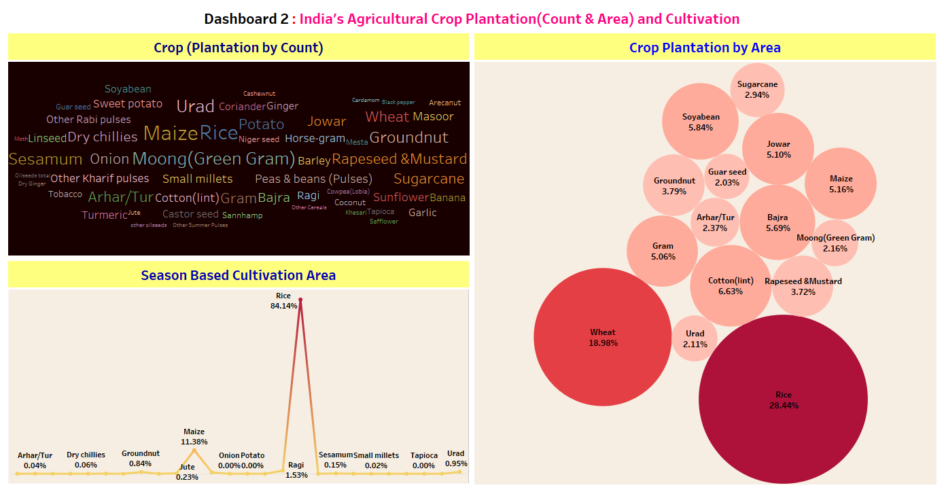

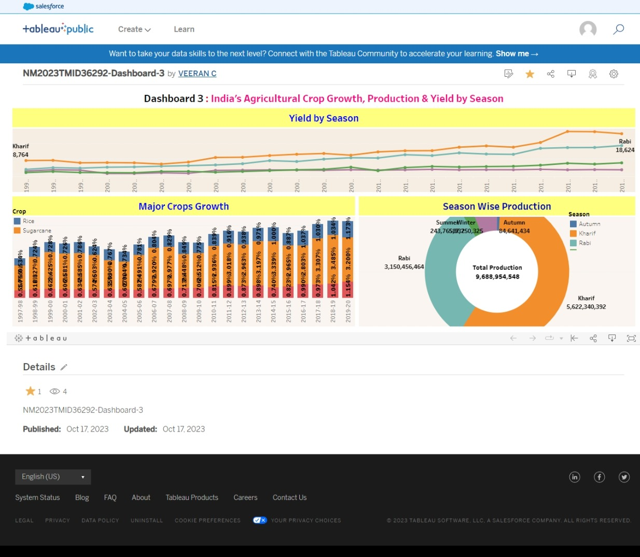

**4. ADVANTAGES & DISADVANTAGES**

It can encompass a wide range of activities and initiatives aimed at improving crop production in the agriculture sector of India. These projects can vary in scope, goals, and approaches. Here are some general advantages and disadvantages associated with such projects:

**Advantages:**

Food Security: Increased crop production can contribute to food security by ensuring a stable and sufficient food supply for the growing population.

Economic Growth: A thriving agriculture sector can boost the country's economy by creating employment opportunities, increasing rural income, and generating export revenues.

Improved Livelihoods: It can enhance the livelihoods of farmers, making their income more secure and helping reduce poverty in rural areas.

Diversification: These projects can promote crop diversification, reducing the risk associated with dependence on a single crop and potentially improving soil health.

Technological Advancements: They encourage the adoption of modern farming techniques and technologies, such as precision agriculture, which can lead to increased efficiency and productivity.

Environmental Sustainability: Some projects can focus on sustainable and environmentally friendly farming practices, reducing the negative impact on the environment.

Research and Development: Investment in crop production projects often leads to increased research and development, leading to innovative agricultural practices and products.

**Disadvantages:**

Initial Investment: These projects often require substantial initial investments in infrastructure, technology, and education. This can be a challenge, especially for developing countries like India.

Land and Water Management: Increasing crop production can put additional pressure on land and water resources, leading to overuse, soil degradation, and water scarcity issues.

Market Uncertainty: Crop production can be affected by market fluctuations and price volatility, which can impact farmers' income and livelihoods.

Climate Change Risks: Climate change can lead to unpredictable weather patterns, affecting crop production and potentially leading to crop failures.

Monoculture Risk: Intensive crop production can sometimes lead to monoculture, where a single crop is grown extensively, making the agricultural system vulnerable to pests and diseases.

Social Disparities: It is essential to ensure that the benefits of increased crop production are equitably distributed, as some farmers may have better access to resources and education than others.

Environmental Impact: While some projects aim for sustainable practices, others may prioritize high yields at the expense of the environment, leading to soil erosion, deforestation, and water pollution.

Regulatory Challenges: Dealing with government regulations, subsidies, and policies can be complex and bureaucratic, which can hinder the success of crop production projects.

The success of a project like "India Agriculture Crop Production" depends on careful planning, effective management, and a holistic approach that considers both short-term and long-term goals, environmental sustainability, and the well-being of farmers and rural communities.

**5. CONCLUSION**

It project presents significant potential advantages and challenges. India's agricultural sector is crucial for the nation's food security, economic growth, and the livelihoods of millions of people. However, achieving sustainable and increased crop production requires a multifaceted approach that addresses various key issues.

The advantages of such a project include enhanced food security, economic growth, improved livelihoods for farmers, crop diversification, technological advancements, and potential environmental sustainability. These benefits can lead to a more robust and resilient agriculture sector, contributing to the overall well-being of the country.

Nonetheless, there are notable challenges associated with these projects, including substantial initial investments, land and water management issues, market uncertainties, climate change risks, monoculture dangers, social disparities, potential environmental harm, and regulatory complexities. Managing these challenges is essential to ensure that the benefits of increased crop production are equitable and sustainable, with a focus on long-term agricultural and environmental health.

The success of the "India Agriculture Crop Production" project hinges on a well-rounded strategy that balances short-term productivity gains with long-term sustainability, environmental stewardship, and social equity. It requires collaboration among government, farmers, researchers, and other stakeholders, along with ongoing monitoring and adaptation to address the ever-evolving challenges of the agriculture sector. Ultimately, achieving a harmonious blend of increased crop production, environmental sustainability, and the well-being of farmers is the ultimate goal for India's agricultural future.

**6. FUTURE SCOPE**

The future scope of agriculture crop production in India is vast, and it is essential to address the evolving challenges and opportunities in the agricultural sector to ensure food security, economic growth, and sustainable development.

The future of agriculture crop production in India relies on innovation, sustainability, and a holistic approach that addresses the evolving needs of the sector. It requires collaboration among the government, private sector, and farming communities to ensure a prosperous and sustainable agricultural future.

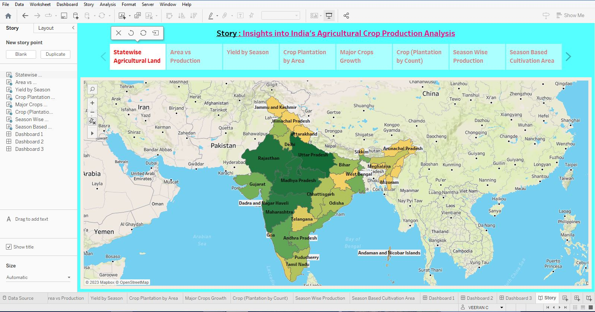**7. APPENDIX**

**TABLUE WORKSPACE**